Statistical analyses and visualisations

For the data analysis and visualization part, I produced three R scripts, six plots, and two .rds model files:

- R Scripts (src/ folder):
- data_processing.R:
Cleans the raw data, reverse-scores questionnaire items, and computes HEXACO, TWQ dimensions, and an overall TWQ score. The cleaned dataset is saved in data/processed_data.csv while the dataset including all raw item responses is saved in data/processed_data_raw.csv.

- data_analysis.R:
Generates descriptive statistics, correlation matrices, and exploratory visualizations (heatmaps and scatterplots).

- mixed_model.R:
Fits Linear Mixed-Effects Models (LMM) to account for the nested data structure (participants within teams) and extracts parameters for the Shiny app. It also performs model assumption checks (residual normality and homoscedasticity), which confirmed that the models are statistically valid.

- Visualizations (figures/ folder):
6 plots in total: Distributions of scores, Correlation heatmap, two faceted scatterplots, Forest plot of the mixed model, and Diagnostic plots (Q-Q plot & Residuals vs Fitted).

- Model Files (src/ folder):
- model_focused.rds: The fitted mixed model for the single-slider app simulation (Support ~ Agreeableness).
- model_multi.rds: The fitted mixed model for the 6-slider app simulation (Overall TWQ ~ All traits).

- Results:
- Descriptives and Correlations
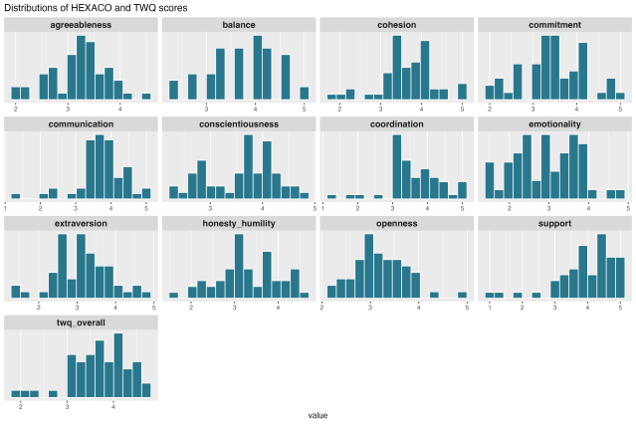 . 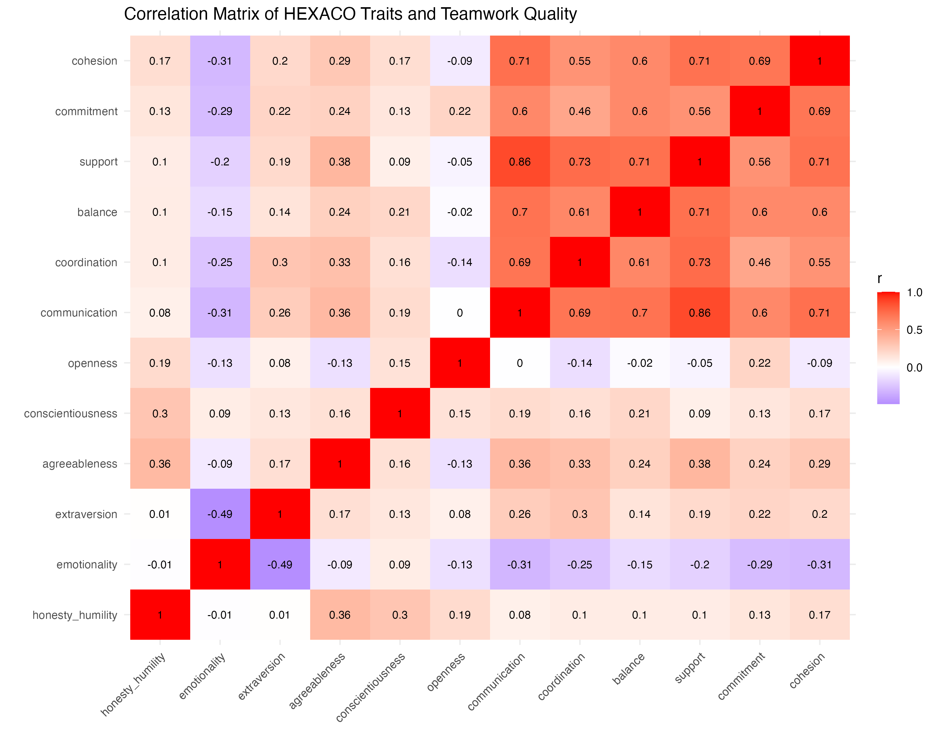
The correlation heatmap shows that the TWQ dimensions are highly inter-correlated (supporting the computation of an overall TWQ score). Across scales, Agreeableness showed the strongest positive association with Teamwork Quality, specifically with Support (r = 0.38) and Communication (r = 0.36). Emotionality showed a negative trend with overall teamwork quality.

- Visualizing Relationships
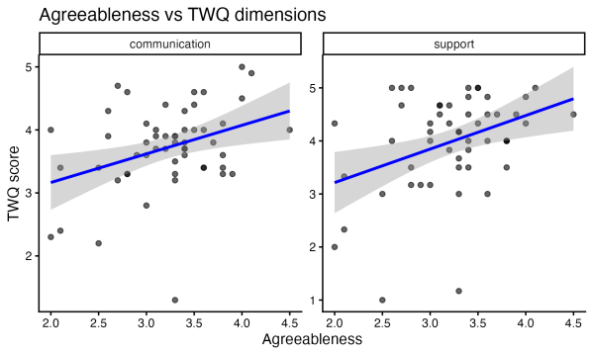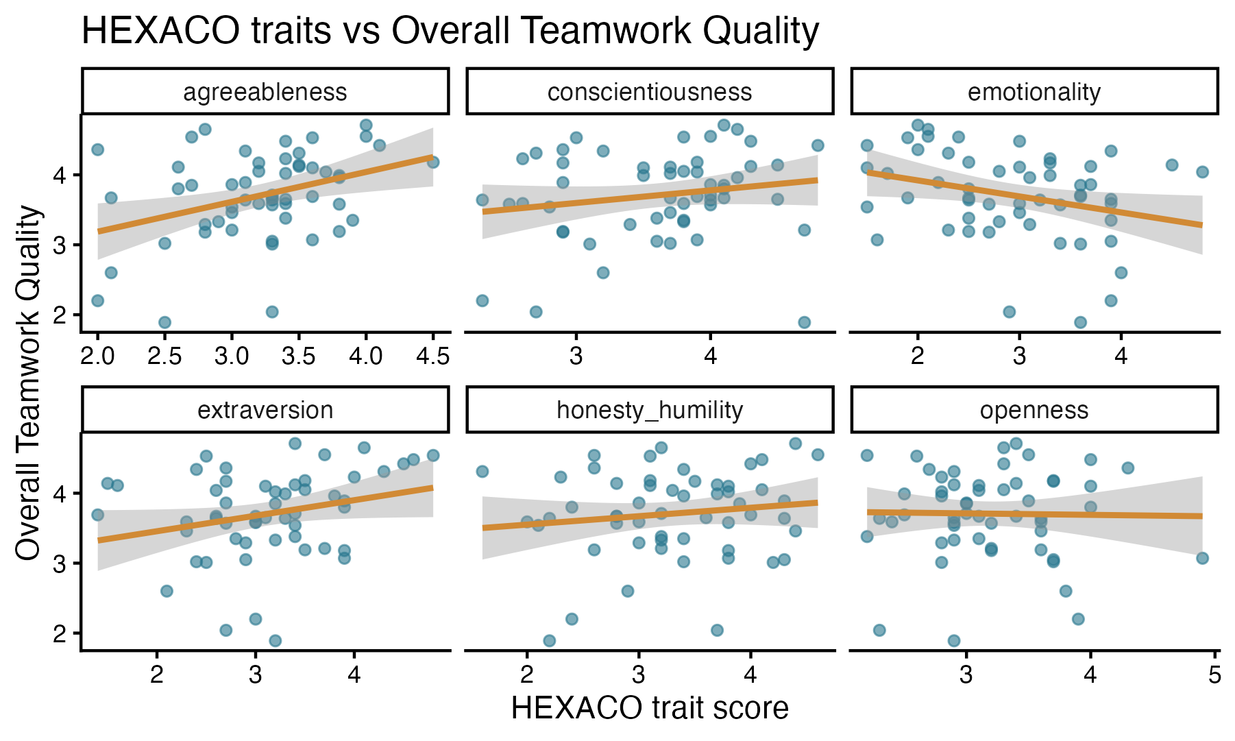
The scatterplots further illustrate these relationships. Higher agreeableness and extraversion are visibly associated with better overall teamwork quality, while higher emotionality is associated with lower teamwork quality.

- Mixed-Effects Model Results
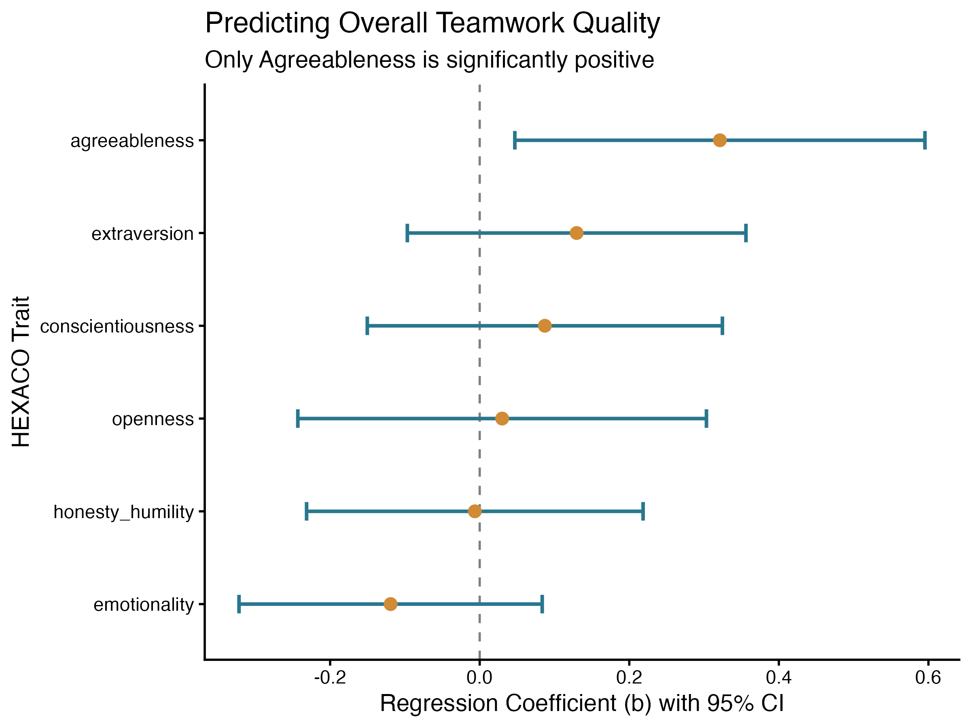
To account for the nested data structure (participants within teams), we fitted mixed-effects models. The focused model predicting Support from Agreeableness was significant (b = 0.45, 95% CI [0.21, 0.91]).

When controlling for all six traits simultaneously (predicting overall TWQ), Agreeableness remained the only significant positive predictor (b = 0.32, 95% CI [0.06, 0.59]). Emotionality showed a non-significant negative trend (95% CI [-0.32, 0.07]).

- Model Assumptions
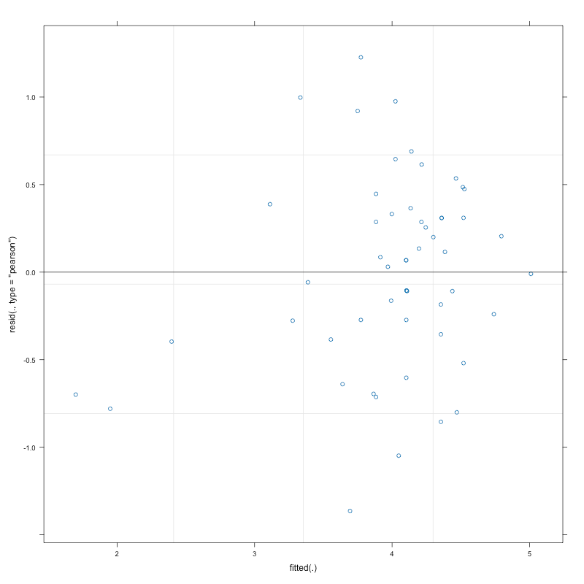
Diagnostic checks confirmed that the mixed models met the assumptions of normality and homoscedasticity. Multicollinearity was not a concern (all VIFs < 1.5).

Limitations: The sample size is relatively small (N = 54 across 13 teams). Therefore, estimates should be interpreted with caution and are reported with 95% confidence intervals. Associations do not imply causation.

